**1. INTRODUCTION**

**1.1 Introduction**

The project “Pocket GPK An android Application” deals with web view of college website through the button on click,. Our program have the real time databases for attendance through checkbox based on Firebase dependency. Teacher can take the attendance and modifiable it, Students can’t do any changes in this application. So, the proxy become difficult .This program can facilitate students explore all the activities happening in the college through e-noticeboard, even students can get to know which teacher / faculty is assigned to which Stream, the current status of a Stream, attendance percentage of a Stream and upcoming requirements of a Stream. Teachers can upload the notice through the [www.blooger.com](http://www.blooger.com) .Students get the study material for study in this android application through the PPTs, PDFs, Document files (.doc), Spread sheets (.xls) and also available the previous paper to prepare for studies and help. Admin and teacher can create the polls through the [www.polleverywhere.com](http://www.polleverywhere.com) which record the data and control from anywhere whenever admin or teacher want.

The purpose of “pocket GPK An Android application” is to automated the college system using online services and make one step ahead to digitalized the college management through the android smartphone which is available everywhere and easy handled .

**2. Planning**

**2.1 Planning**

In the system engineering a specification is a document that clearly and accurately describe the essential technical requirement for items, materials or services including procedures by which it can be determine that requirement have been met. Specification help avoid duplication inconsistencies allow for accurate estimate of necessary resource, act as a navigation and reference document for consistence document for engineering changes, provide documentation and configuration, and allow the configuration communication among those responsible for the eight primary function of system engineering. They provide a precise idea of the problem to be solved so that they can efficiently design the system and estimate the cost of the design.

**2.1.1 Purpose**

This system can be used as an application for the Welfare of collage and ultimately to digitalized India Dream, to manage college management and students and teachers interaction through the Android smartphone. The system is an online application that can be accessed throughout the college students and teachers manage through the Admin (uppermost bodies of college) for attendance, which will give better service to the manage the attendance.

**2.2 Estimation**

Many factors can influence outcome of IT project to of most important determinants are up font planning and estimation. Yet this are often challenging of many companies. And for good resume accurately gauging the project efforts, schedule, cost and resources requirement can be difficult. Given the most project estimate aren't accurate the project planning equally suffers, can software development organization realistically experts their project to go against the noun and finish within their allocated schedulers and budgets.

**2.2.1 How Good Is Estimation?**

A well crafted estimate creates many benefits

* Alignment between the business objectives and technical estimates.
* More formed Business decision making.
* Reliable project delivery dates.
* Controlled project costs.
* Improved communication between management and project team.

**3. Technological Review**

**3.1 Android Studio**

Android Studio is the official integrated development environment for Google's Android operating system, built on JetBrains' IntelliJ IDEA software and designed specifically for Android development. It is available for download on Windows, macOS and Linux based operating systems It is a replacement for the [Eclipse Android Development Tools](https://en.wikipedia.org/wiki/Eclipse_(software)#Android_Development_Tools) (ADT) as the primary IDE for native Android application development.

* [Gradle](https://en.wikipedia.org/wiki/Gradle)-based build support
* Android-specific [refactoring](https://en.wikipedia.org/wiki/Code_refactoring) and quick fixes
* [Lint](https://en.wikipedia.org/wiki/Lint_(software)) tools to catch performance, usability, version compatibility and other problems
* [ProGuard](https://en.wikipedia.org/wiki/ProGuard_(software)) integration and app-signing capabilities
* Template-based wizards to create common Android designs and components
* A rich [layout editor](https://en.wikipedia.org/wiki/Graphical_user_interface_builder) that allows users to drag-and-drop UI components, option to [preview layouts](https://en.wikipedia.org/wiki/WYSIWYG) on multiple screen configurations[[16]](https://en.wikipedia.org/wiki/Android_Studio#cite_note-16)
* Support for building [Android Wear](https://en.wikipedia.org/wiki/Android_Wear) apps
* Built-in support for Google Cloud Platform, enabling integration with Firebase Cloud Messaging (Earlier 'Google Cloud Messaging') and Google App Engine[[17]](https://en.wikipedia.org/wiki/Android_Studio#cite_note-17)
* Android Virtual Device (Emulator) to run and debug apps in the Android studio.

**3.2 XML**

XML is use to design the layout. All the UI and layout of your app is designed using xml.  
Unlike Java (which is Back Bone of your app), xml helps you to design your app , how it will look , how components like buttons , textView , etc will be placed and their styling.   
Apart from these , xml is also used for parsing data either from database or server into your android app.(Xml parsing).

In Android Studio, you will see all the projects' XML files and can edit them with all the tools Android Studio provides, including the visual designers. As you make changes and save them in Android Studio, they will automatically reflect back into your Elements project inside Visual Studio

**3.3 Firebase**

**Firebase** provides a real time database and backend as a service. The service provides application developers an API that allows application data to be synchronized across clients and stored on **Firebase's** cloud. Cloud Firestore which is **Firebase's** next generation of the Real time Database was released for beta **use**

**3.4 Java**

Java technology's versatility, efficiency, platform portability, and security make it the ideal technology for network computing. From laptops to data centers, game consoles to scientific supercomputers, cell phones to the Internet, Java is everywhere!

**3.5 Web Applications**

Now-a-days so much web applications are available to perform the specific task which create a specific link through which we can perform the task we want and data is stored in the uploading site or posting side while response comes from new (dedicated link).

We uses two web Applications. They are follows:

1. **Blogger**

Blogger is a blog-publishing service that allows multi-user blogs with time-stamped entries. It was developed by Pyra Labs, which was bought by Google in 2003. The blogs are hosted by Google and generally accessed from a subdomain of blogspot.com. We use blogger to provide notice to students and provide its link in the Pocket Gpk through the Image Button and students can directly interact with the notice.

**ii) Poll Everywhere**

Poll Everywhere is a privately held company headquartered in San Francisco, California. The company, founded in April 2007 .PollEverywhere is an online service for classroom response and audience response systems. Poll Everywhere's product allows audiences and classrooms in over 100 countries use mobile phones, thereby "plotting the obsolescence" of proprietary hardware response devices otherwise known as clickers.

We created an account of “pocketgpk477” and a link generated by the pollEverywhere through which the students can participate in the survey polls. Just like Notice board ,we provide link of generated link in the “Pocket Gpk” through the Image Button.

**4. REQUIREMENT SPECIFICATION**

**4.1 Software Requirement**

The Software Requirements in this project include:-

• JDK 1.7 or above

• Firebase real time Database

• Internet Explorer, Mozilla Firefox, Google Chrome etc.

**4.2 Hardware Requirement**

Hardware Required For Project Development:-

• 4 GB Ram minimum.(Recommended 8GB)

• 1 TB Hard Disk Minimum.

• Intel i3 Processor or above

**5. UML DIGRAM**

**5.1 Use Cases Diagrams**



Admin

Manage the Survey Questions

Students

Use case for Admin

Use Case for Teacher

Login for Attendance**StuentAdmin Acivitr PDFs, Documell lls through tyhe android application through the PPTs, PDFs, Documernt files()with curriculum**

View College Cell

Take Attendance

Upload notification

Take Survey of Students

Teacher

View Notification

Take part in Survey

View Notes and

other study material

Student

Login for assuring

Attendance record

Use case for Students

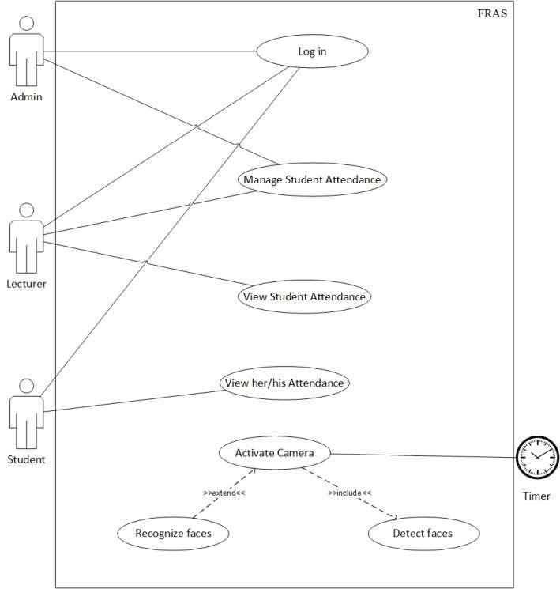

Use Case Diagram for e-Attendance

**6. MODULES**

**6.1 Home Activity**

This interface from where teacher, students and guest can interact with other modules using Intent. On this Module, all available function able modules are Connected here. And they can be access it by Click On each ImageButton.

**6.2 College Main Activity**

This Activity is Web view of College Website to get direct interact with college website on a single click to view the college. This Activity reduces and more reliable than browse the [www.gpk.edu.in](http://www.gpk.edu.in) on browser which saves times and efforts.

**6.3 Attendance Main Activity**

This is the authority login form act as a admin. It can handle all the accounts of students. It is to add/remove teacher and the students, upload the Attendance , manage database etc.

This have the sub activities

* Admin
* Can add/remove teacher
* Can add/remove student
* can upload the attendance of day
* can view the record of attendance
* can change the password and Logout
* Teacher
* Take the Attendance according to period
* Check the previous Attendance record according to date(dd-mm-yyyy)
* Log out
* Students
* Can view the attendance
* Along with either check the status it’s eligible for exam or not using color indication
* Log out

**6.4 Notice Board Activity**

Provide notice to Students. Also students get notice about the companies for their recruitment. It is useful for all branches students for knowing the activities and up-to date about notifications. Information about each activities going in currently in campus but also get notice about the national level Tournaments notifications through this Activity.

**6.5 Study Material Activity**

This is the all over study material for the students to get notes and study data from PPTs, PDFS, .docs, .xls files can find and easy downloaded from here not only notes but also the previous papers, model answer question papers are available here.

Here in this activities have 5 Sub Activites:

* Msbte papers: to download the previous papers from this link.
* PDTs Finder: you can search the pfds related to your topic.
* PPTS Finder: you can search the ppts related to your topic.
* Documents :you can find the information about your Topic.
* Spread Sheets :you can find the information about your Topic in the tabular form.

**6.6 Survey Activity**

This is the polls created by Admin or By teachers for knowing the interest and check the mentality of the students. Students can give Their thoughts through this module so this helps teacher to understand the problems of students and take the proper schedule so they can related there time with curriculum as well as their personal life.

**6. About Activity**

This Activity shows the persons evolve in the development process of Pocket Gpk Android Application under the Guidance of the Prof M.M Andhare sir.

**7. PERFORMANCE ANALYSIS**

**7.1 Introduction**

We will be using mainly a unit testing of our components. We will test each component by sending the component inputs and analyzing the outputs without analyzing the code used to create the functionality. Each of our components we are testing corresponds directly to a requirement in our requirement document.

**7.2 Test team**

As this project is being developed by me and my group member, test team will include mean d my friends. However, the units testing will employee a team of selected individuals for bug reporting.

**7.3 Quality control**

We will maintain the quality of the testing process by developing and of likely to give quality feedback after testing. In unit testing phase, because they don't see it as infallible. This will help ensure that we have the highest quality of testing possible.

**7.4 Test Strategy**

**7.4.1 Testing Process**

The majority of our testing will be done through Unit testing. A unit is the smallest testable part of software. It usually has one or a few inputs and usually a single output. In procedural programming a unit may be an individual program, function, procedure, etc. In object oriented programming the smallest unit is method, which may belongs to base/super class, abstract class or derived class/child class.

**7.4.2 Technology**

Fact that most of our system is GUI-based and requires a person’s for visual inspection to make sure that application is running correctly. In the event that we need to write unit tests we will write our own testing framework. We are not utilizing existing testing framework because the number of tests that we expect will be needed is not a great number and the overhead of the learning a framework and incorporating these into our code will be unneeded complexity.

**7.5 Purpose of the System**

The entire scope has been classified into Four streams known as:

**1. Admin Level:-**

Addressing the information management needs of Teacher And students by administrator for attendance only

**2. Teacher Level:-**

Attendance of students taken by Teacher

**3. Student Level:-**

Student can view attendance only.

**4. Guest Level:-**

Rather than attendance teacher, student and outsiders can view other activities such as view college website, notice and answers polls..

**7.6 Phases:**

The project is envisaged to be completed in three phases. The initial phase will be the creation of a Home layout their connectivity with other modules(College tour, Attendance management, e-Notice Board , Study Materials, Survey Questions and About). The second phase of development will extend the functionality of the each module to allow its aim for ex, College to get connect with the college website means web view activities are done here . The third phase of development will extend the functionality of the about and attendance management using Real Time Database Firebase in tree structure to maintain the record dynamically and modification also done in the layout using splash logo of GPK during starting of “pocket gpk.apk” with duration of 1000 milliseconds.

**8. SNAP SHOTS**

**8.1 Splash Activity**



**8.2 HomeMain Activity**

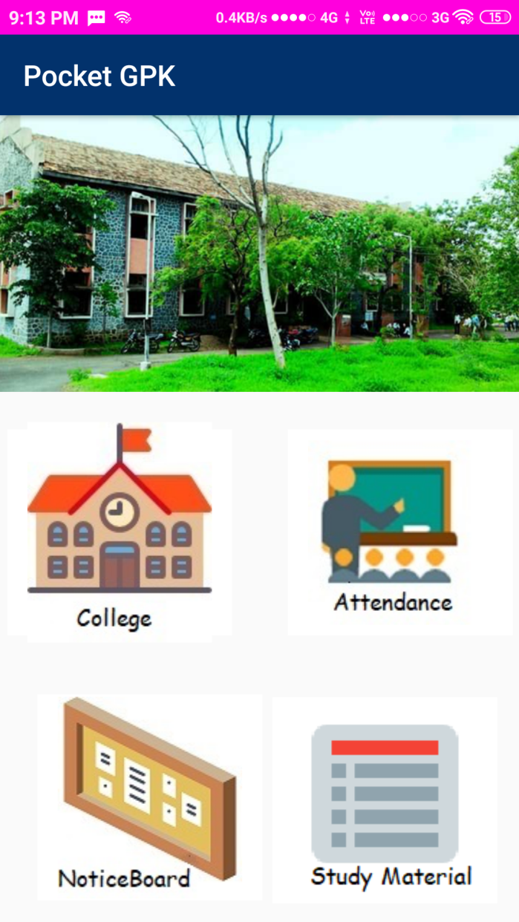 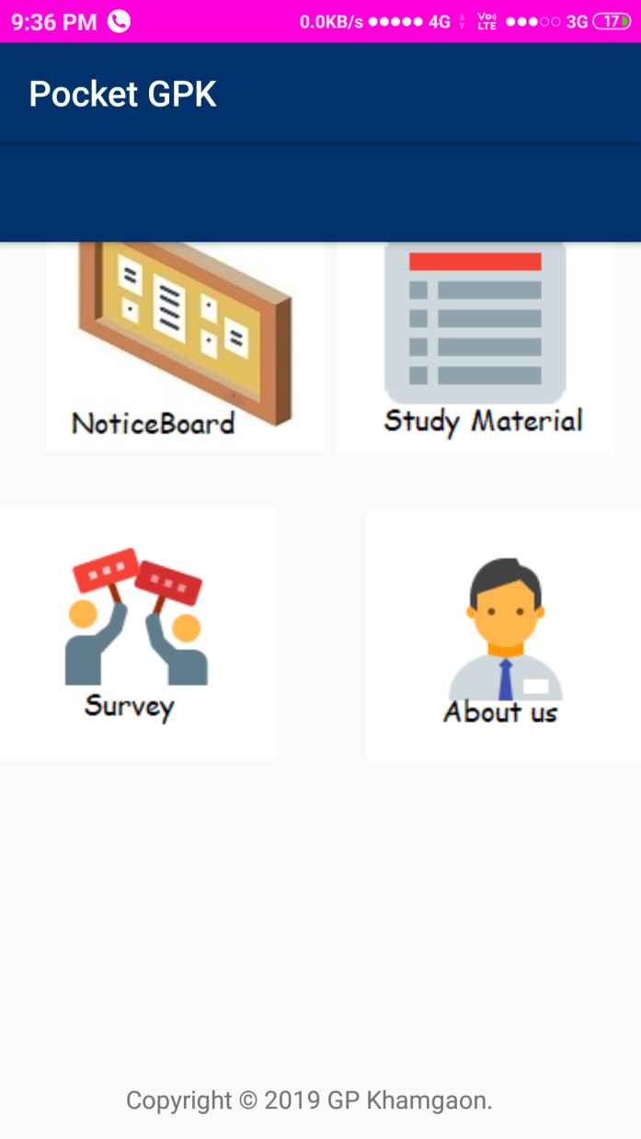

**8.3 CollegeMain Activity**

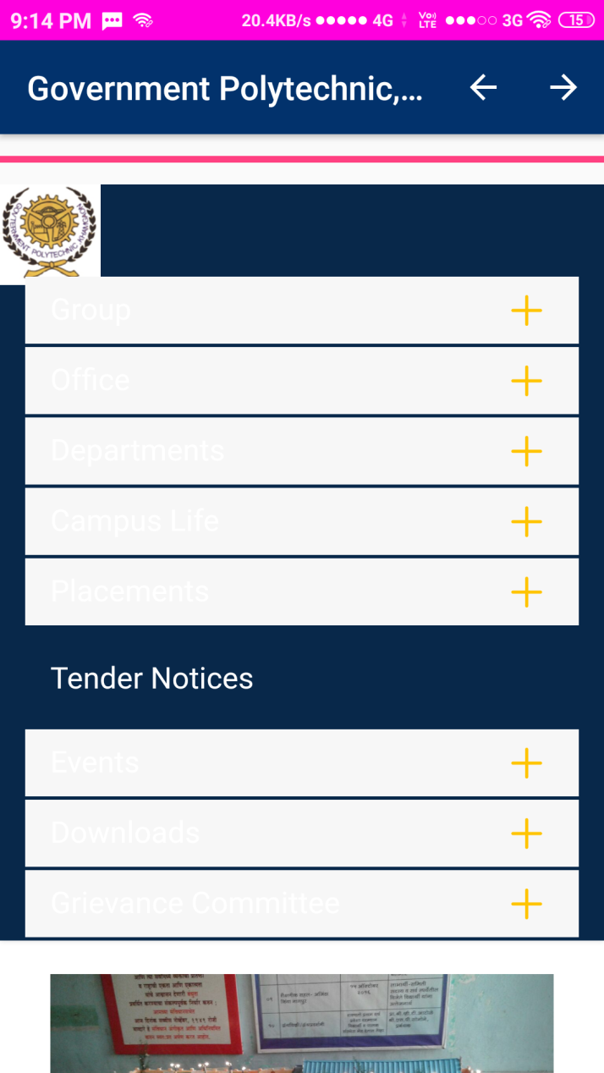 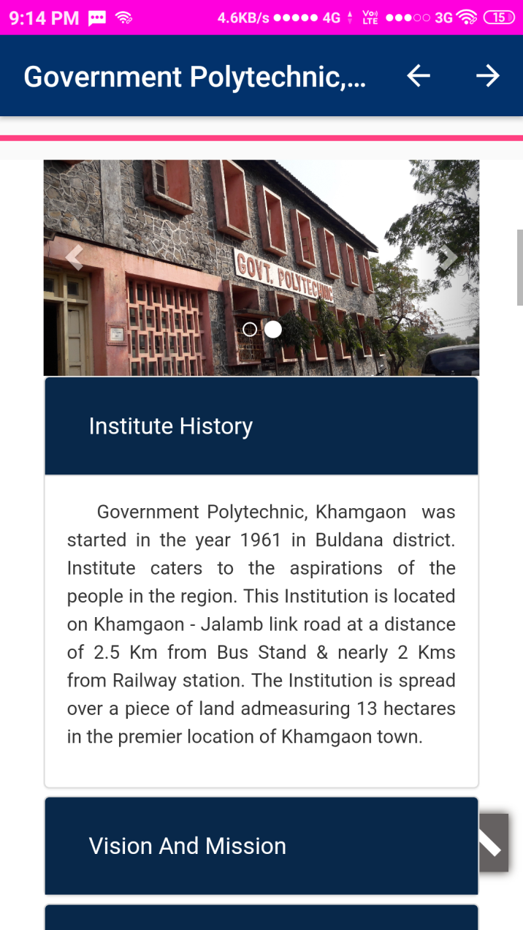

**8.4 Attendance Activity**

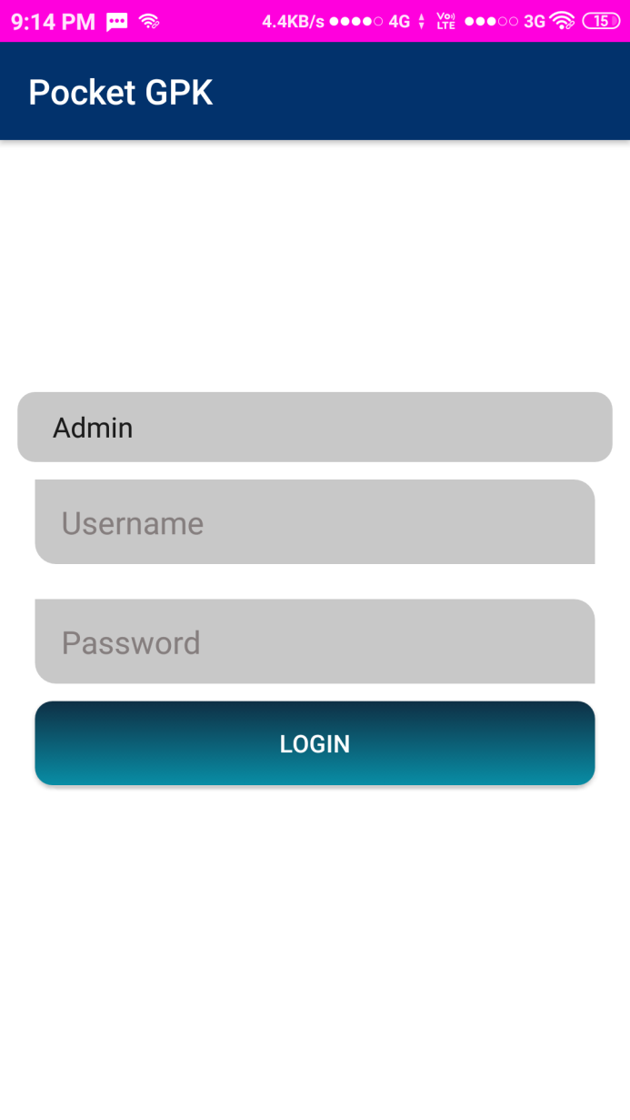

**8.4.1 Admin Activity**

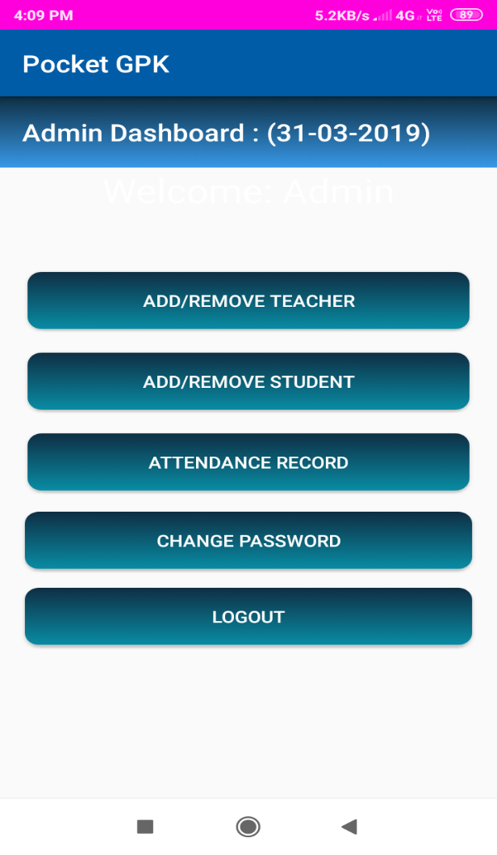 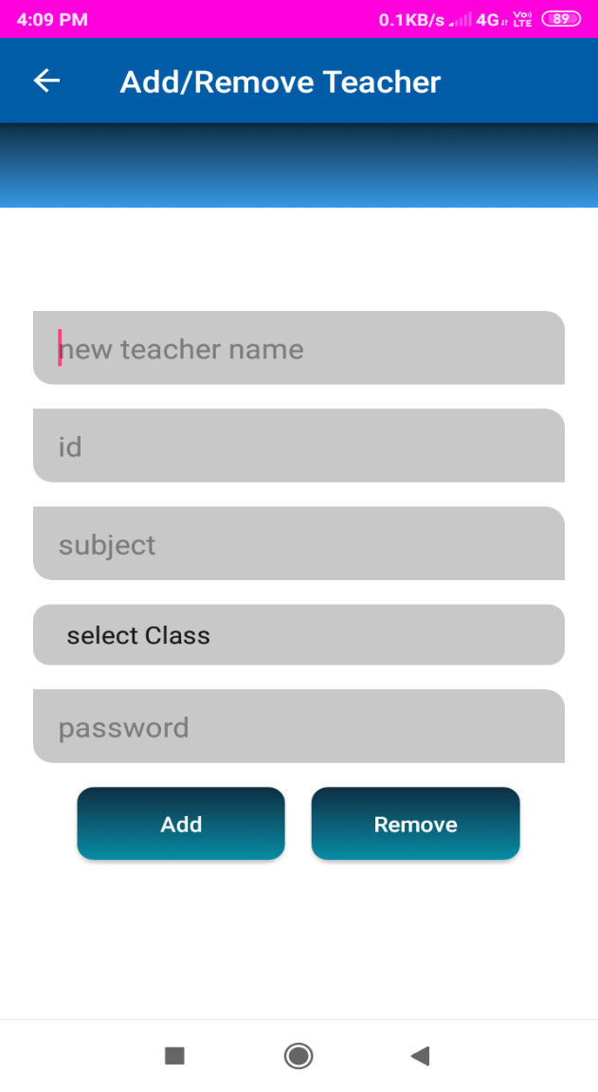

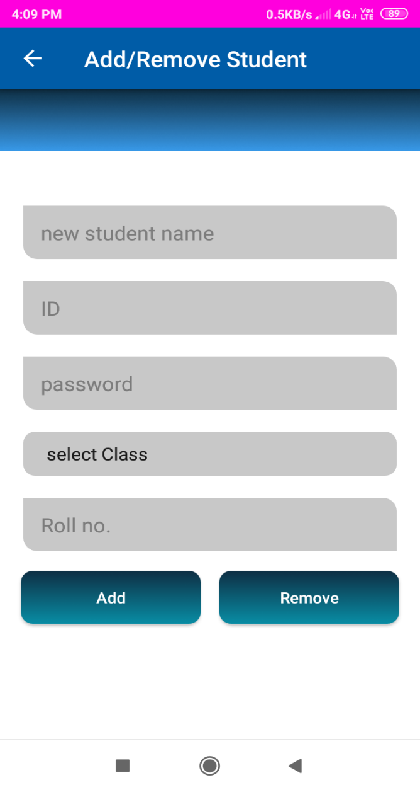 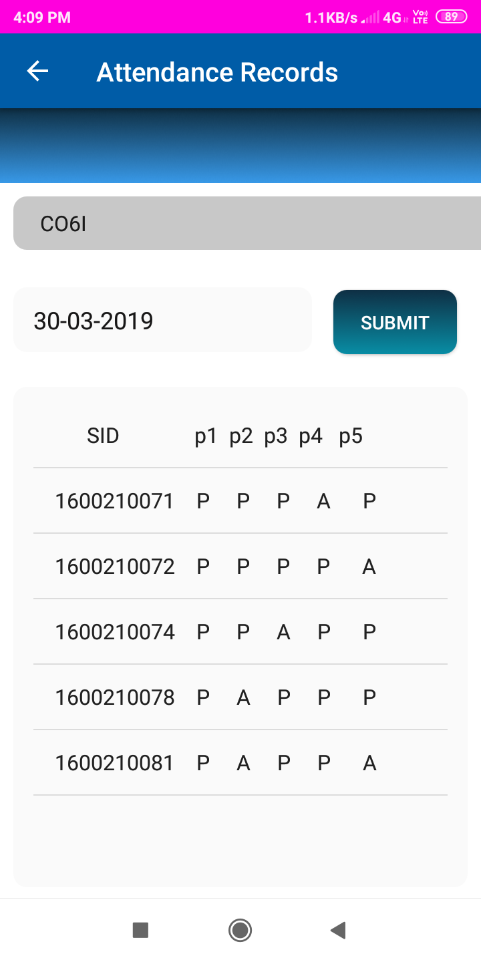

**8.4.2 Teacher Activity**

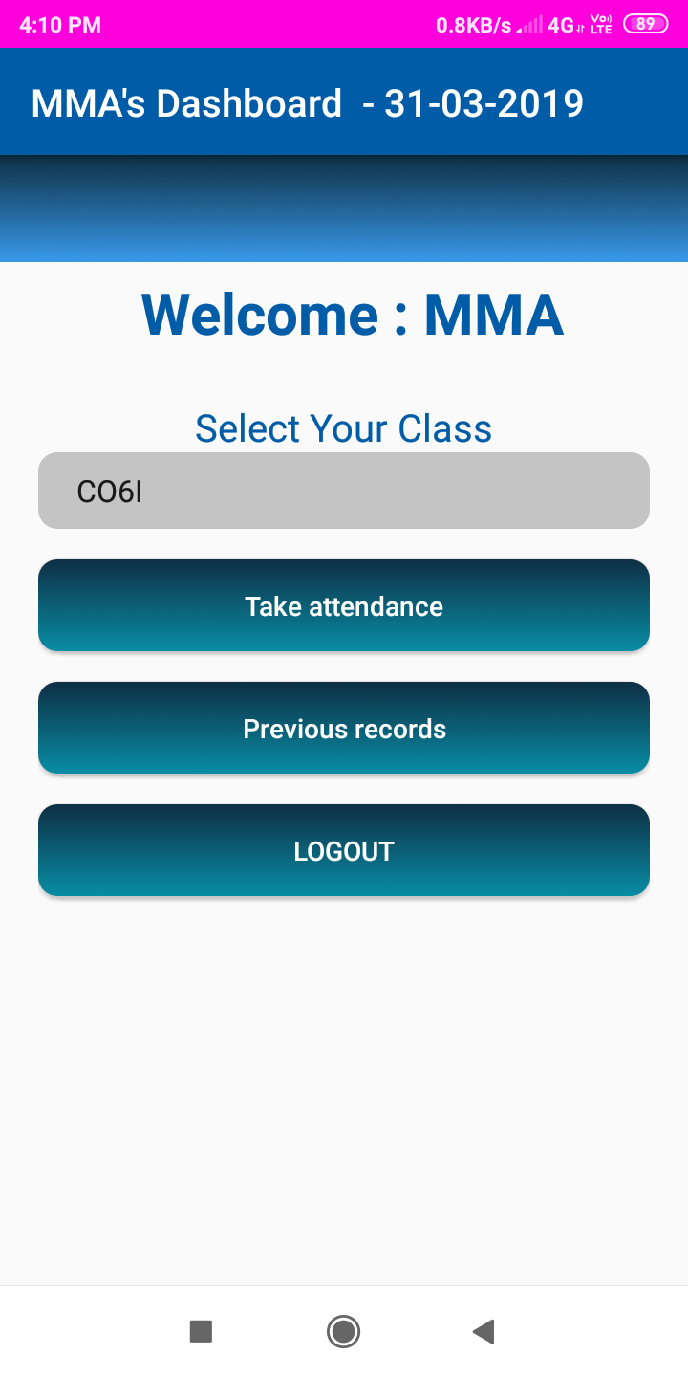 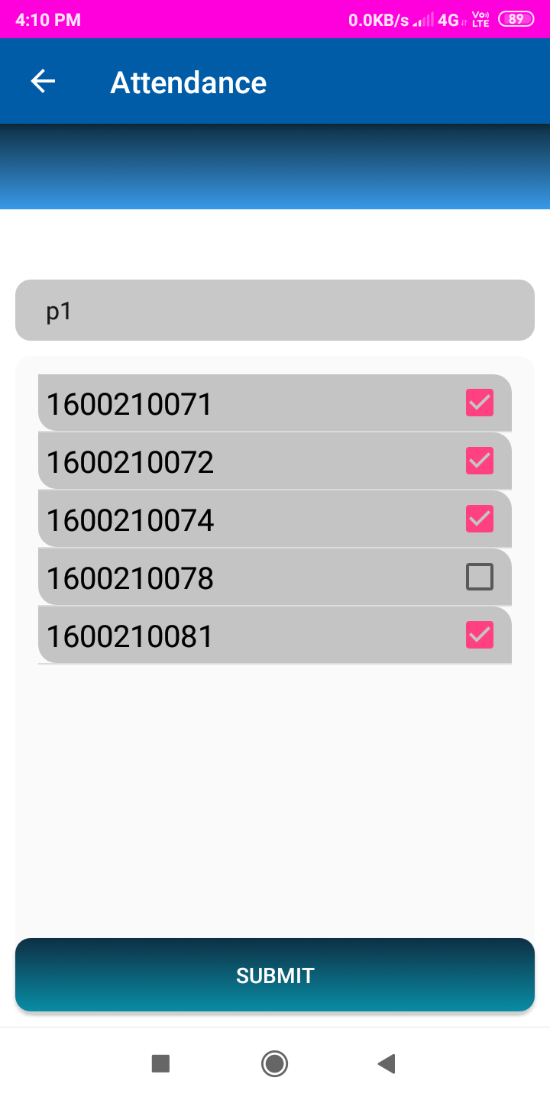

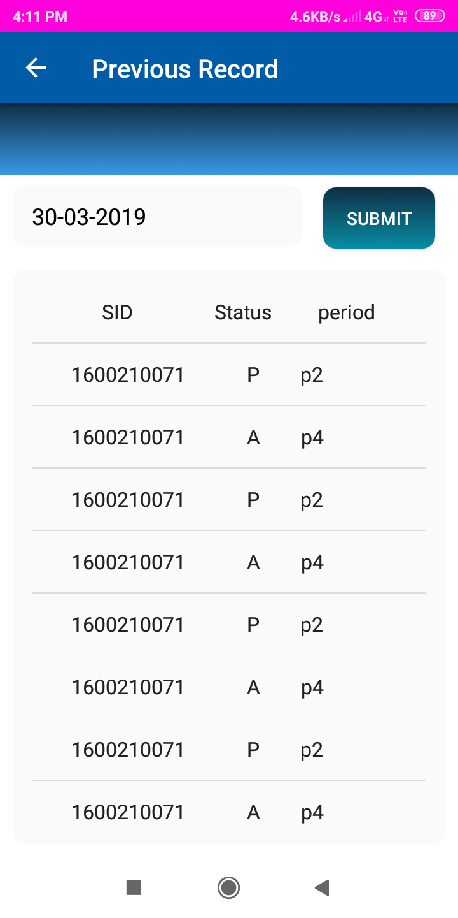

**8.4.2Student Activity**

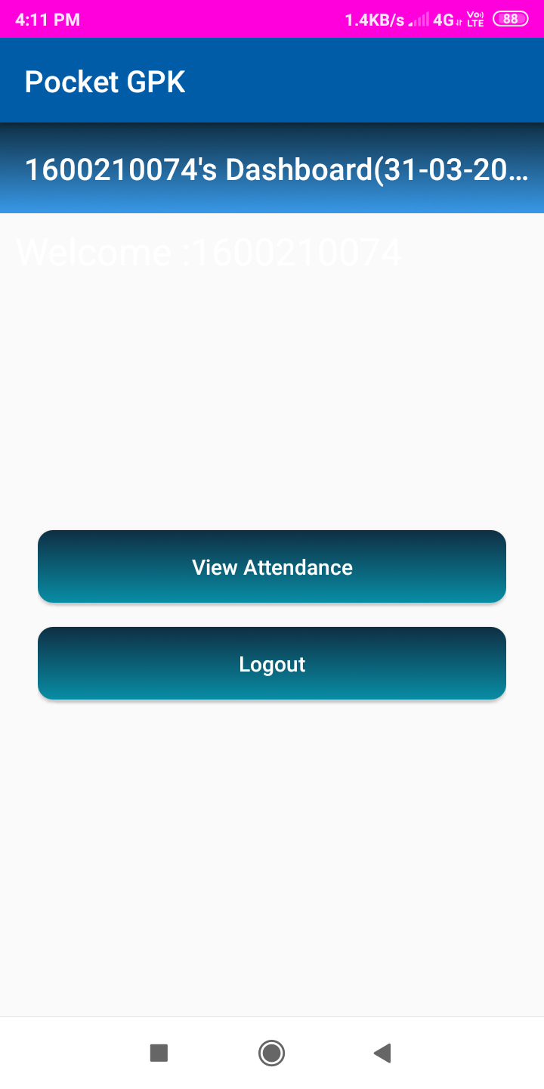 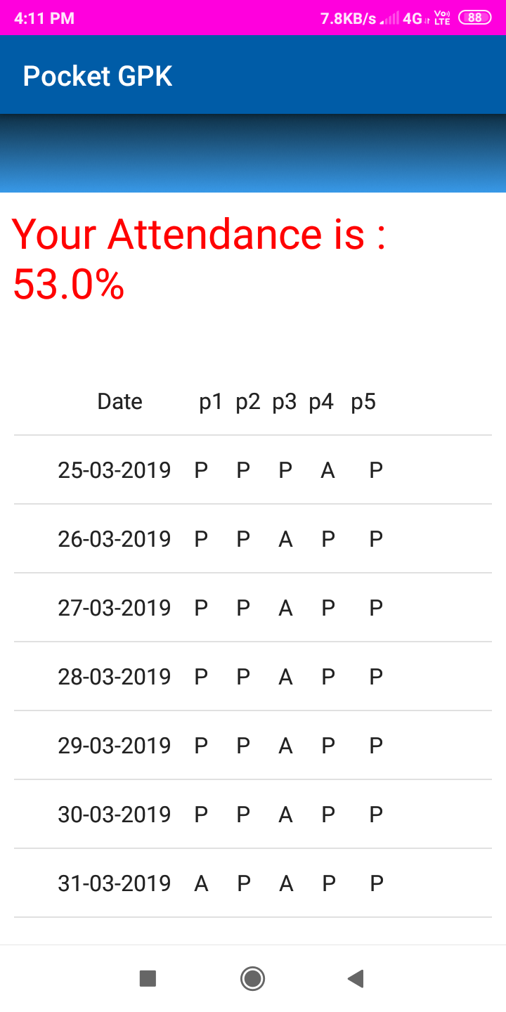

**8.5 Notice Board Activity**

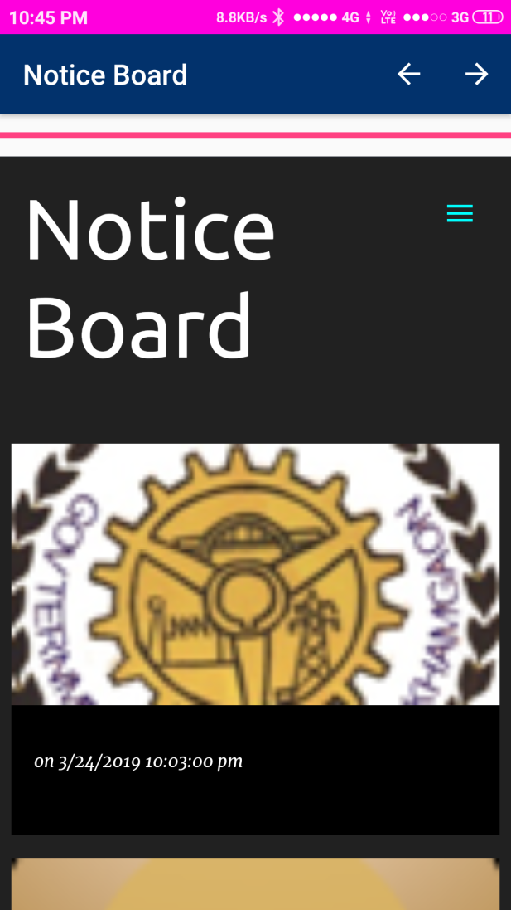 

**8.6 Study Material Activity**

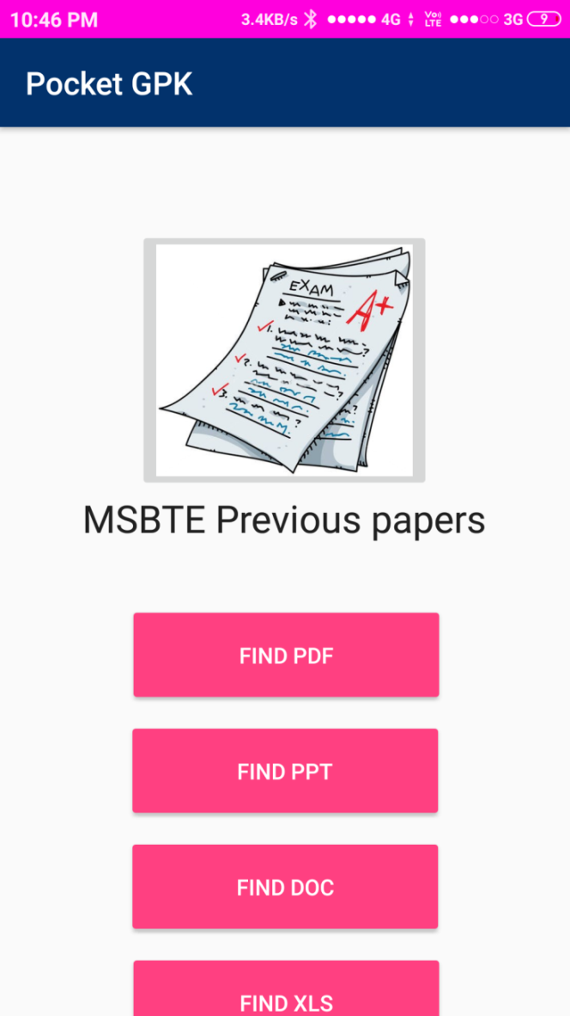 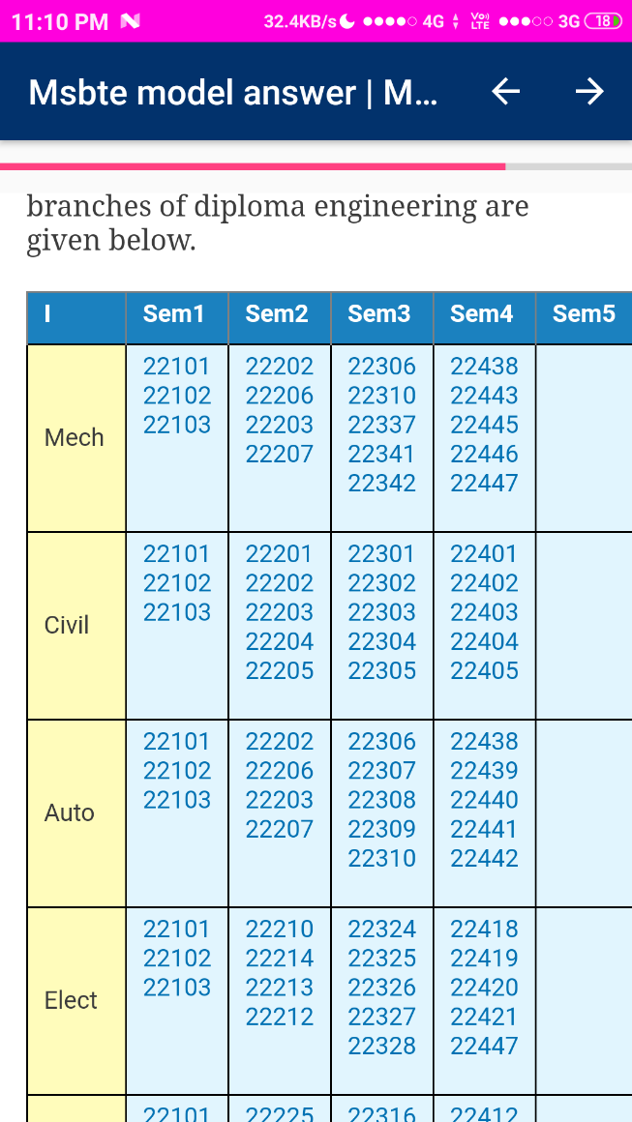

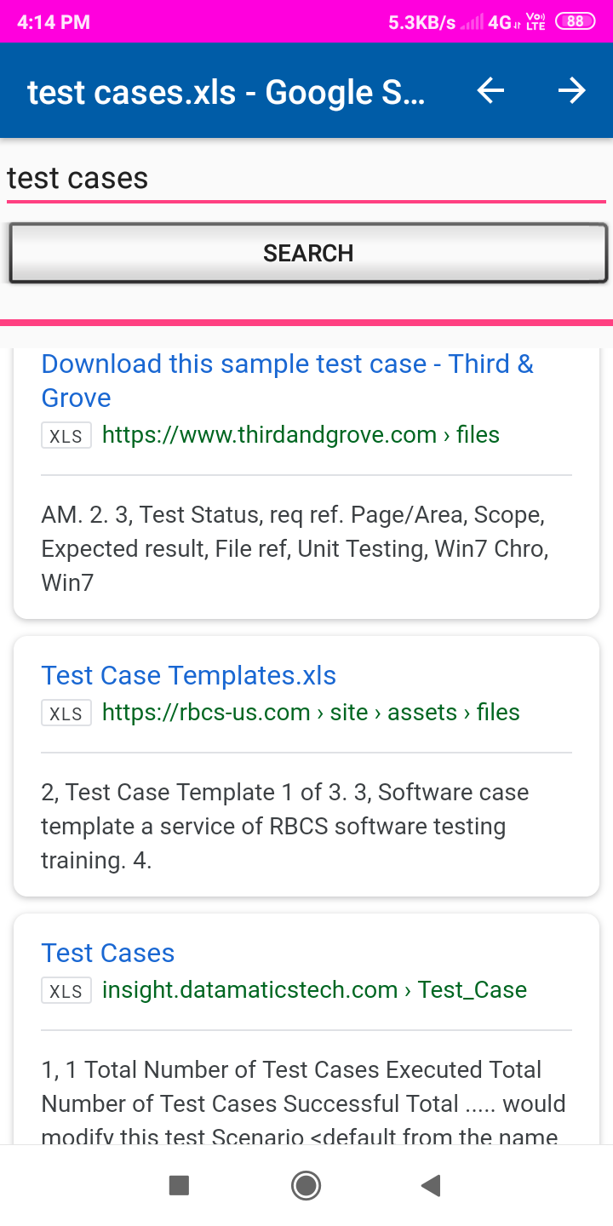

**8.7 Survey Activity**

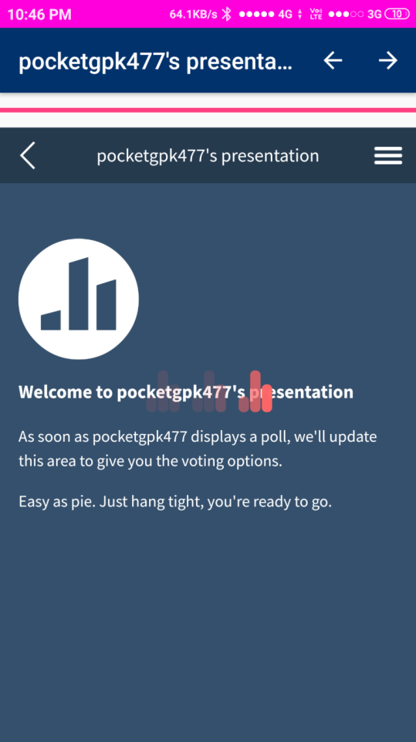 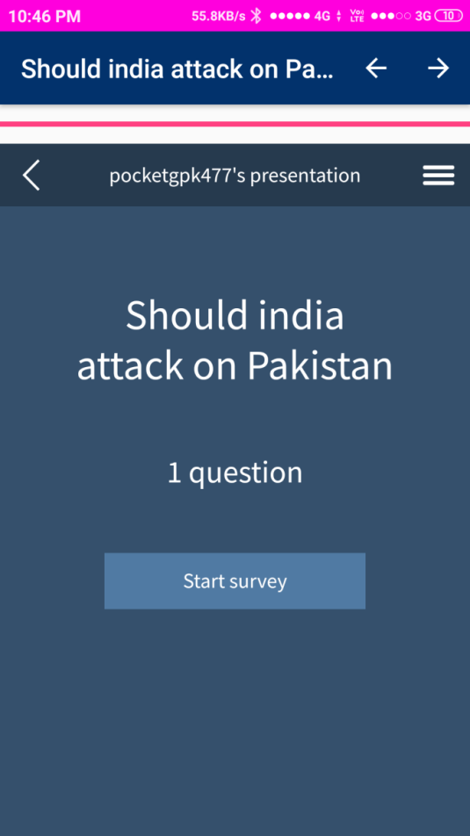

/

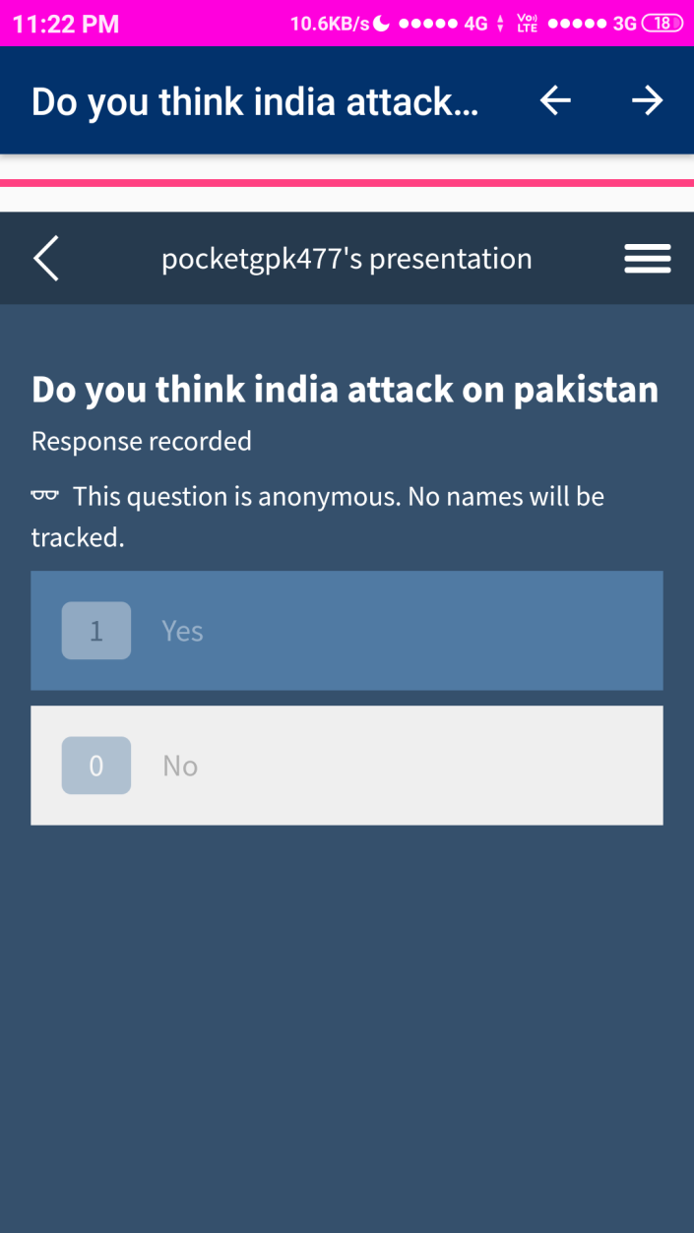 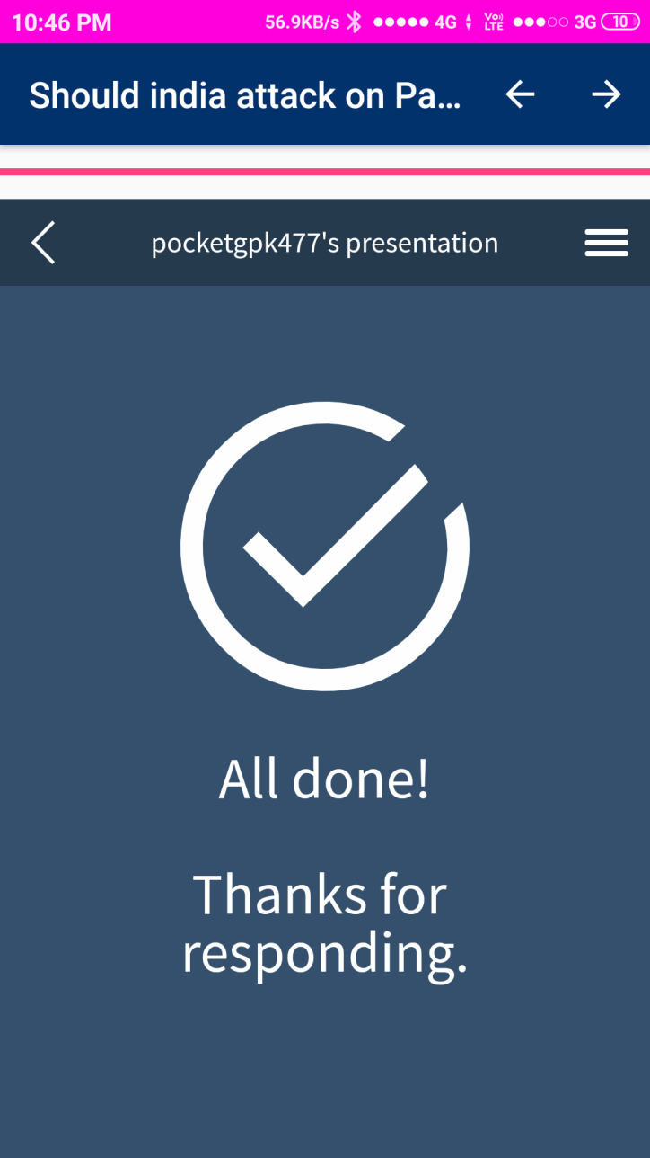

**8.8 About Activity**

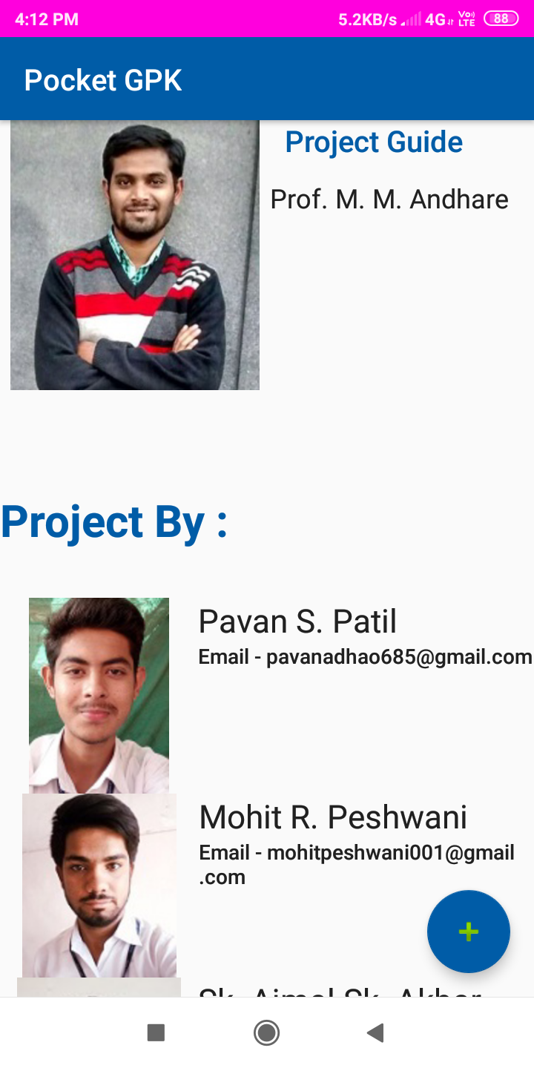 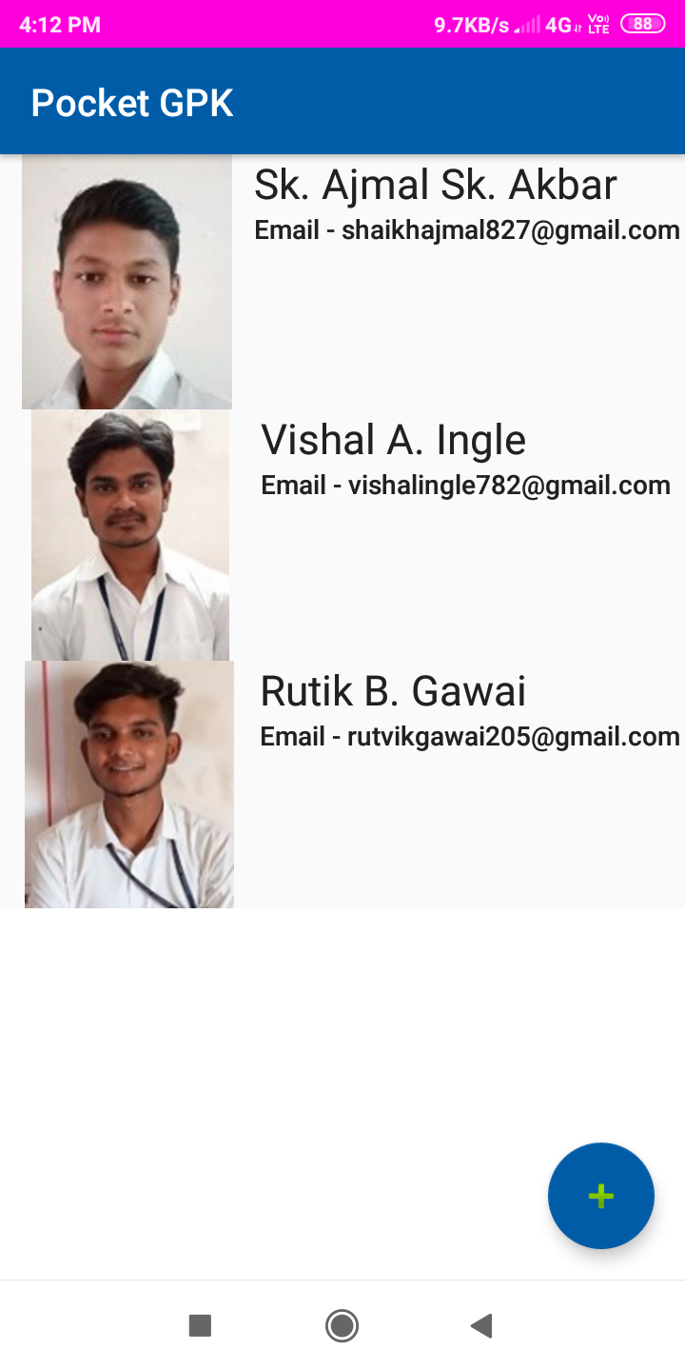

**9. Future scope**

**Future Scope**

An android application will able online class through the concept of video conferencing and will digitalized the documents and verify through the Digital Signature which is secure and strongly Authenticate with the help of parse -js / Firebase cloud platform documents like Benefited, Scholarship form and other forms related to academics.. This android application will manage Library system ,Canteen system.

**10. Conclusion**

**CONCLUSION**

It helps modifying the existing system to digitized the system through the android application.. This is a paperless work. It can be monitored and controlled remotely. It reduces the manpower required. It provides accurate information always. Malpractice can be reduced. All gathered and extra information can be saved and can be accessed at any time. The data which is stored in the project helps in taking intelligent and quick decisions by the management. So it is better to have a cloud based Information Management system. All the teachers and students can get the desired information without delay. This system is essential in the college.

**11. Reference**

* [**http://www.ibm.com/developerworks/libray**](http://www.ibm.com/developerworks/libray)
* [**http://www.java.sun.com/products/java**](http://www.java.sun.com/products/java)
* **https://www.developers.android.com**
* **https://firebase.google.com/docs/database/android/**
* [**https://www.tutorialspoint.com/android/**](https://www.tutorialspoint.com/android/)
* **http://www.javapoint.com/android**